Supplementary Materials for:

**Optimising an evolutionary experiment to evolve nitrogen-fixing legume symbiosis in *Mesorhizobium australicum* BR1-1-5xICE*Ml*Sym**

**Nodulation Assessment Photographs**

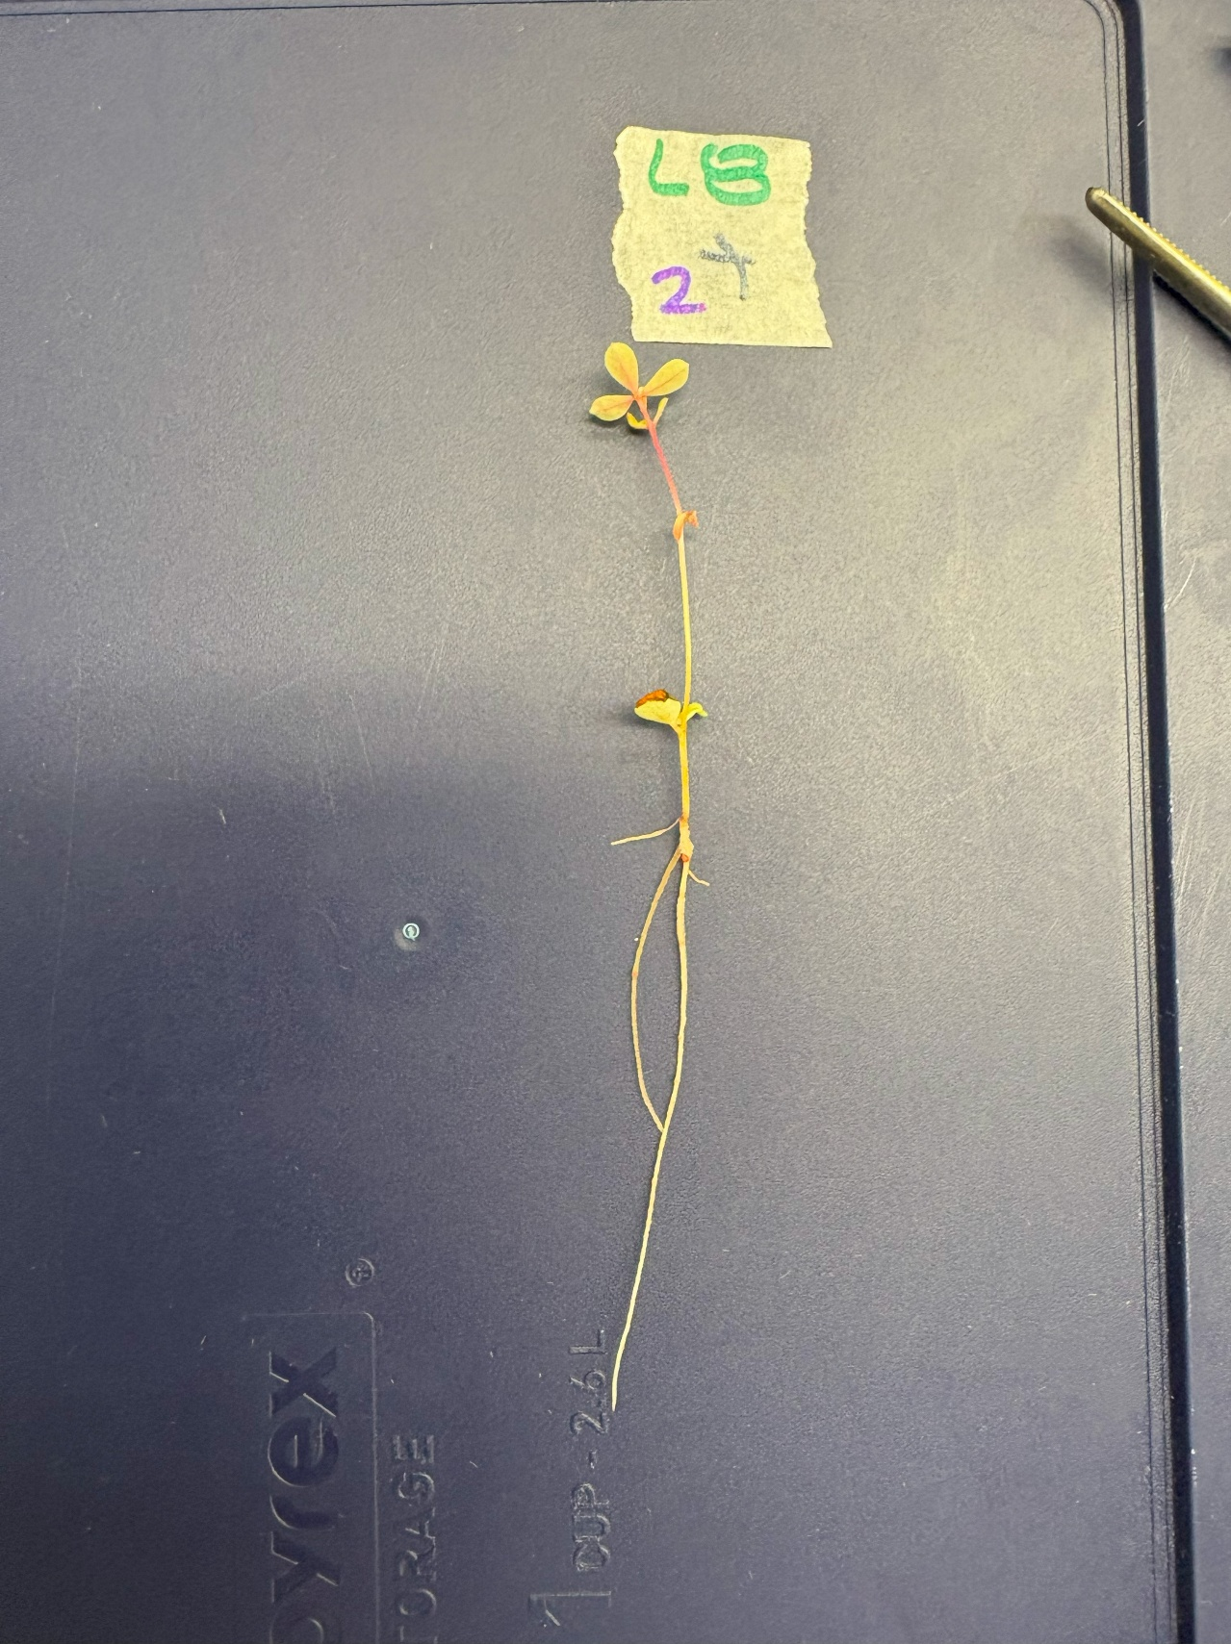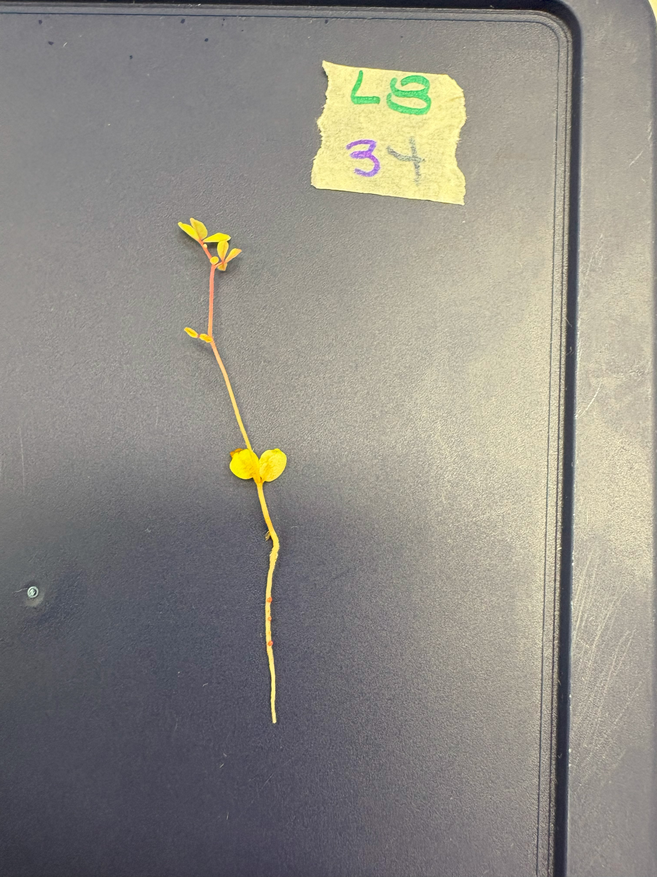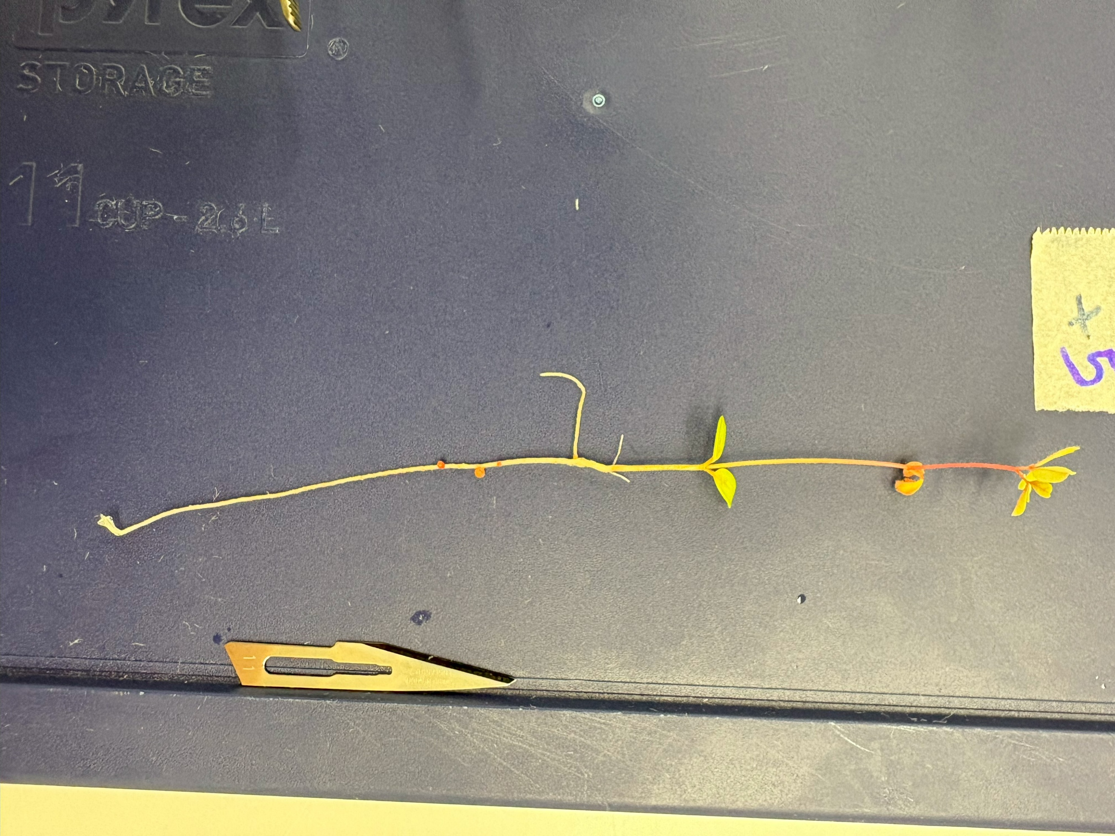

**Supplementary Fig 1.** *L. rectus* Tas2206 nodule-presenting subjects (from left to right: L8+2, L8+3, L8+5). Note the red-coloured nodules present on the roots of each subject

**Supplementary Fig 2.** *L. australis* ID#3 nodule-presenting subjects (from left to right: L4+2, L4+6, L4+7). Unfortunately, do to resting position of the plant, lighting, and the absence of red pigment, the nodules are difficult to observe in these photographs. As such, the nodules have been highlighted for convenience.

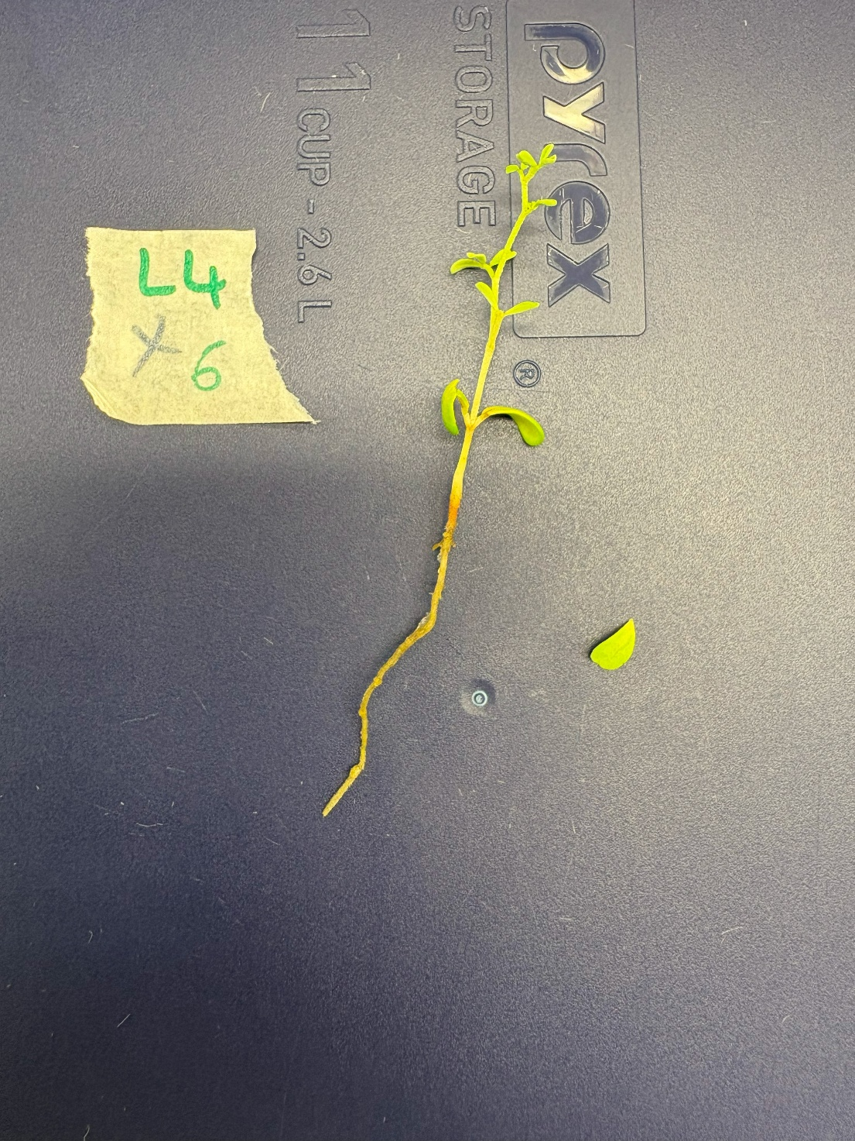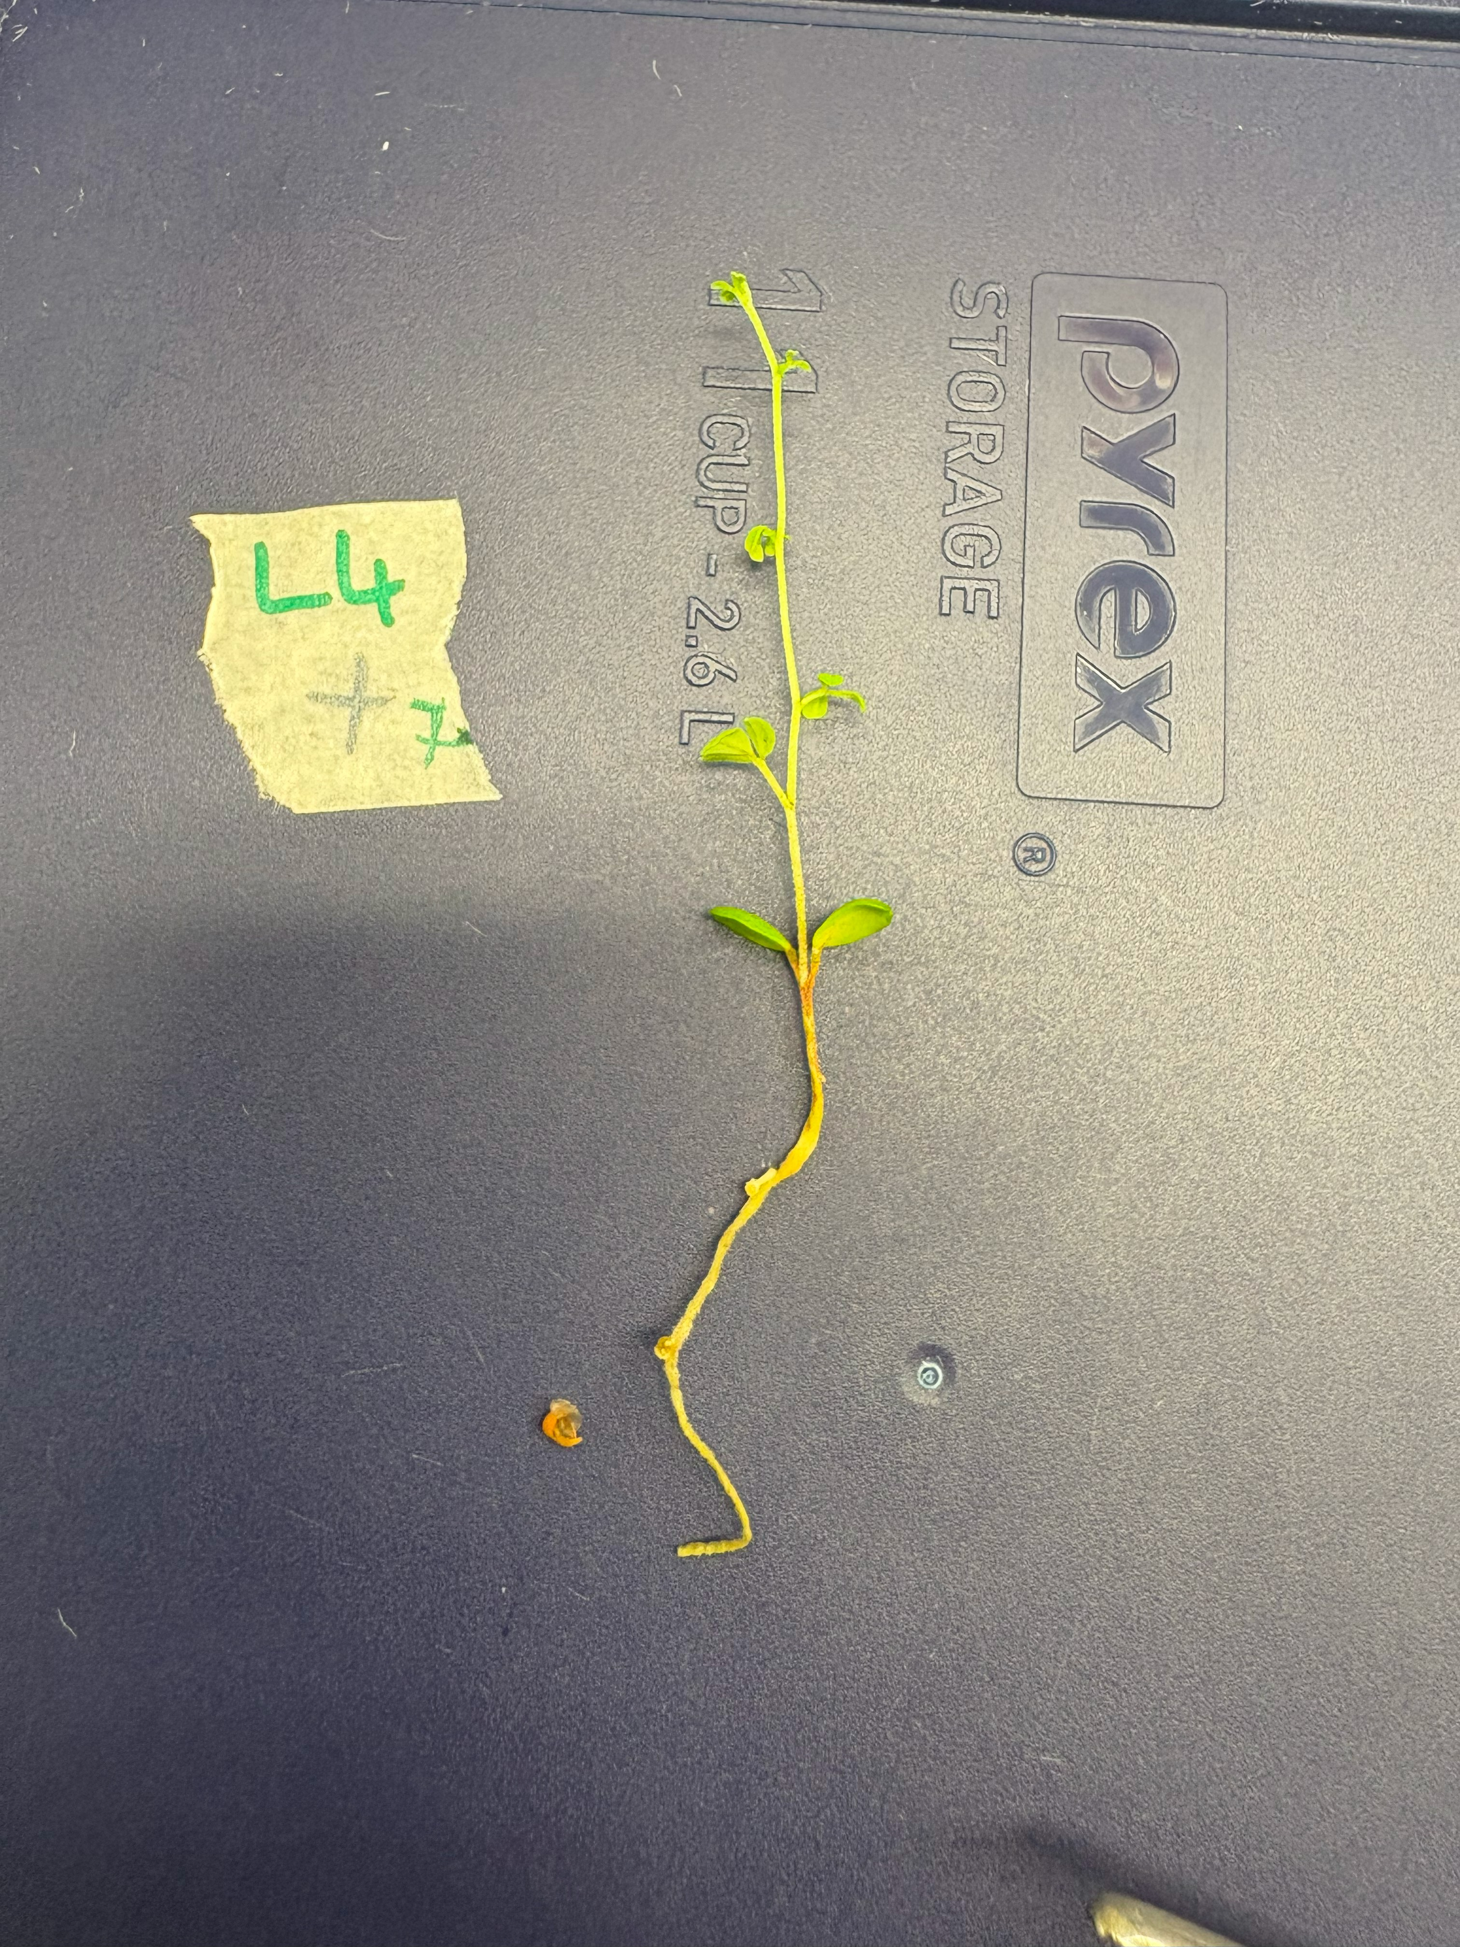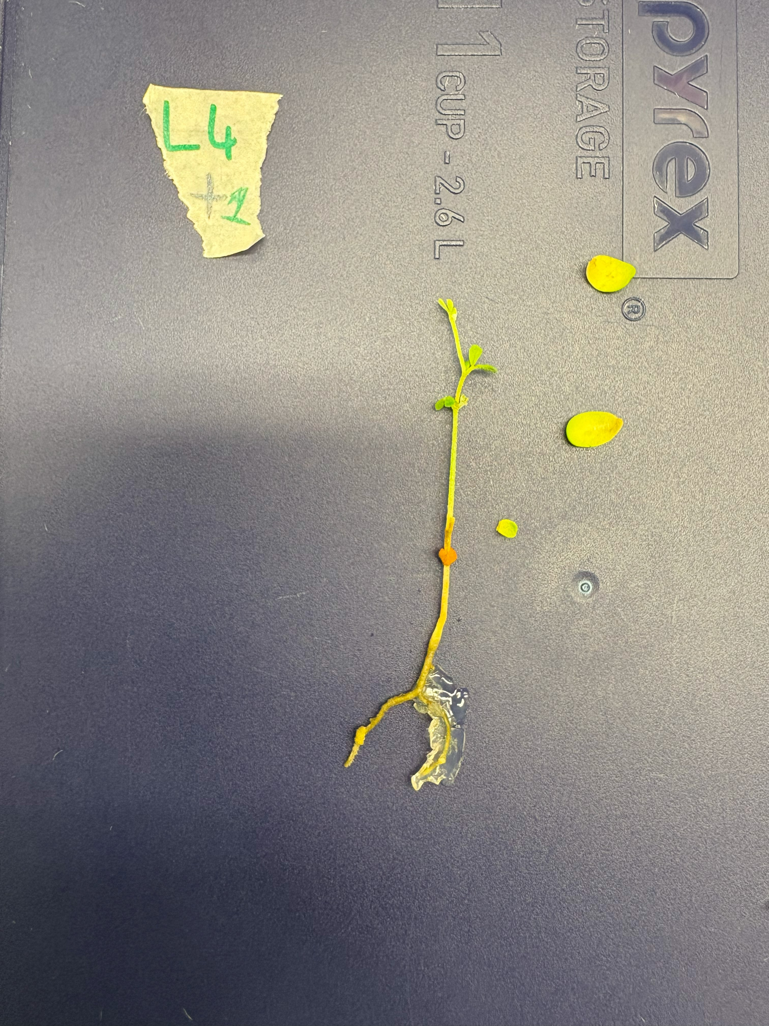

**Supplementary Figure 3a.** *L. uliginosus* GLOC005 bump-presenting subjects (left: L7+2, right: L7+3).

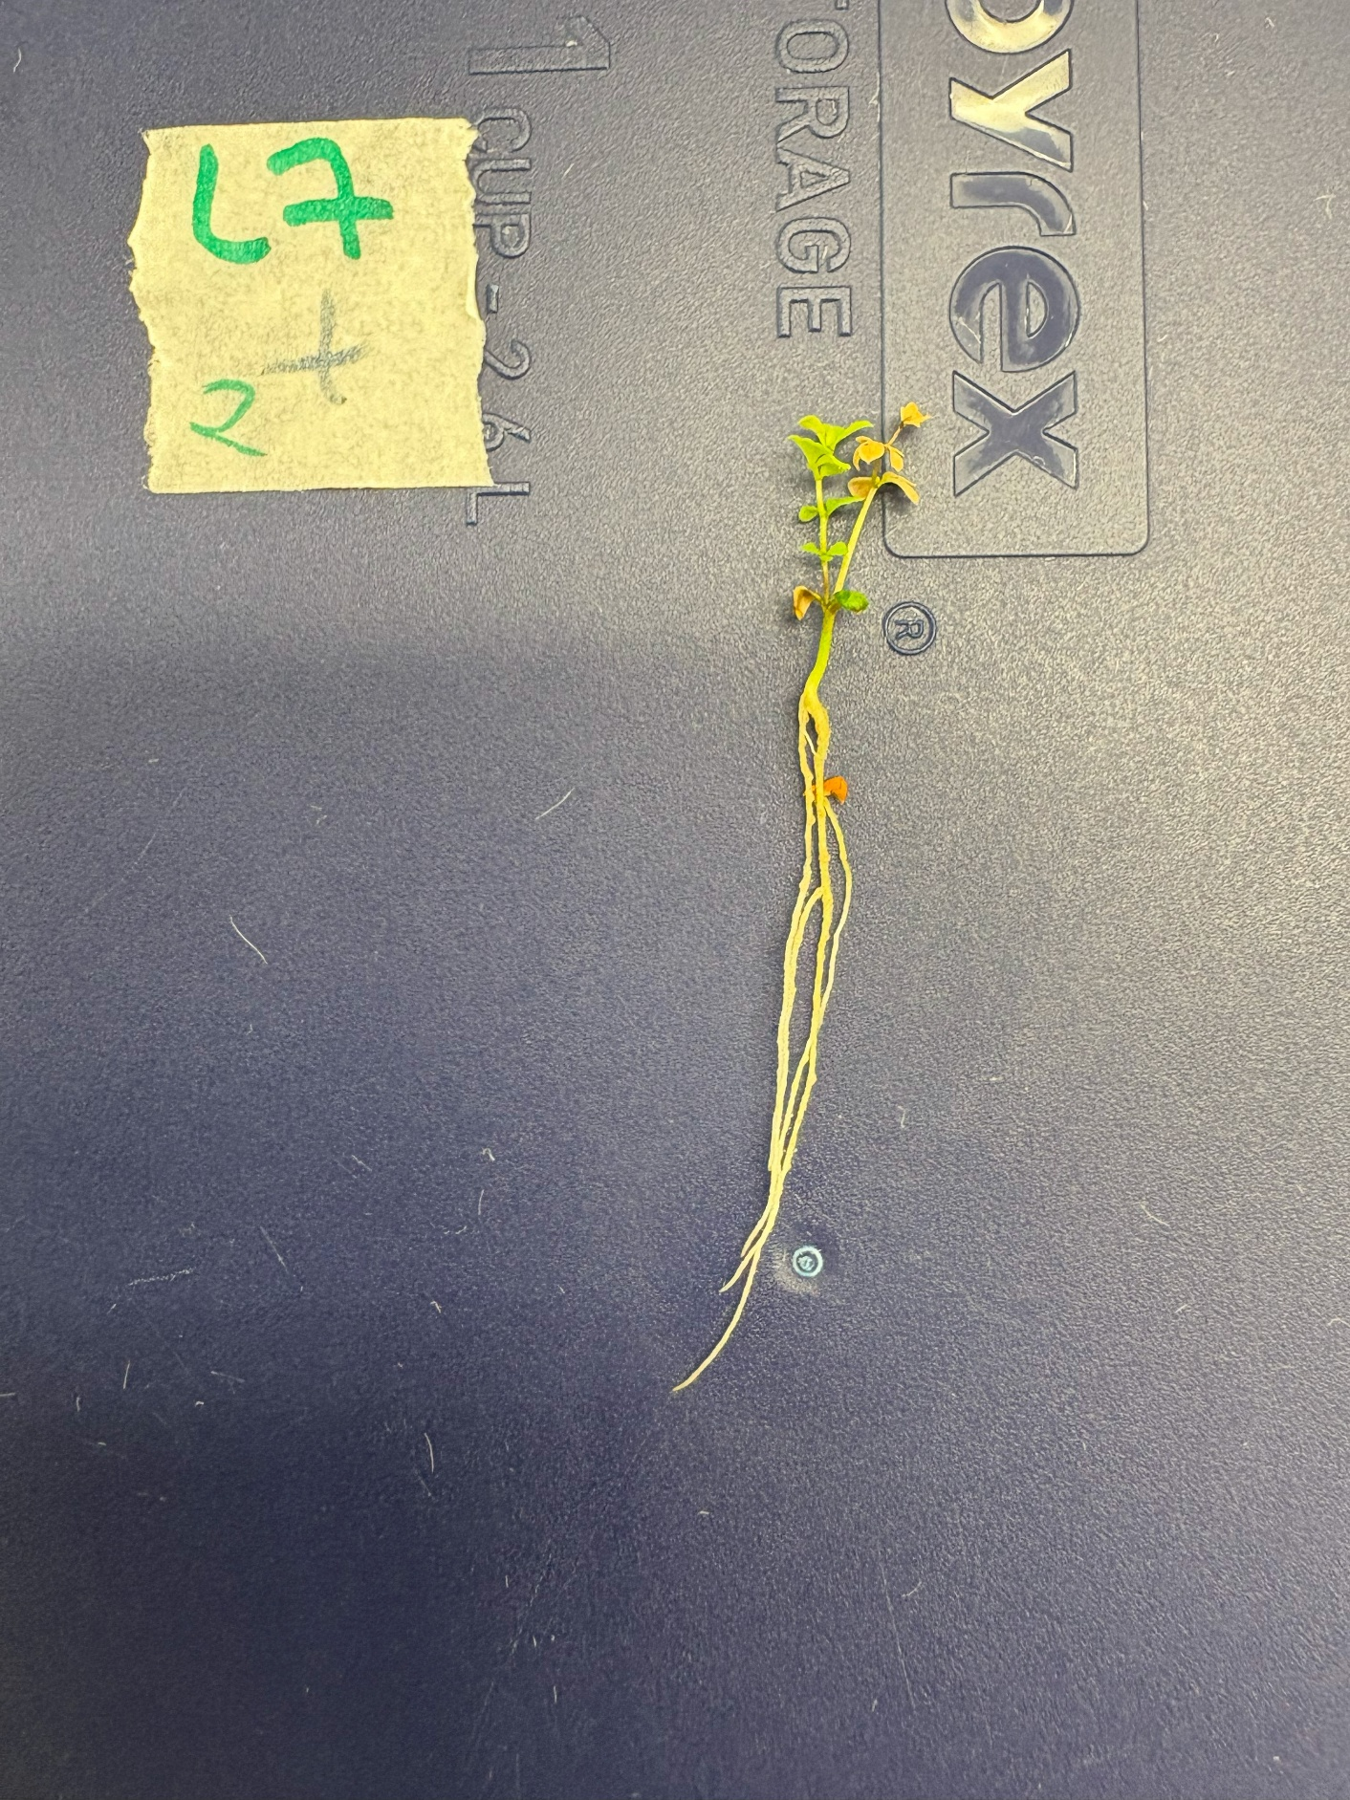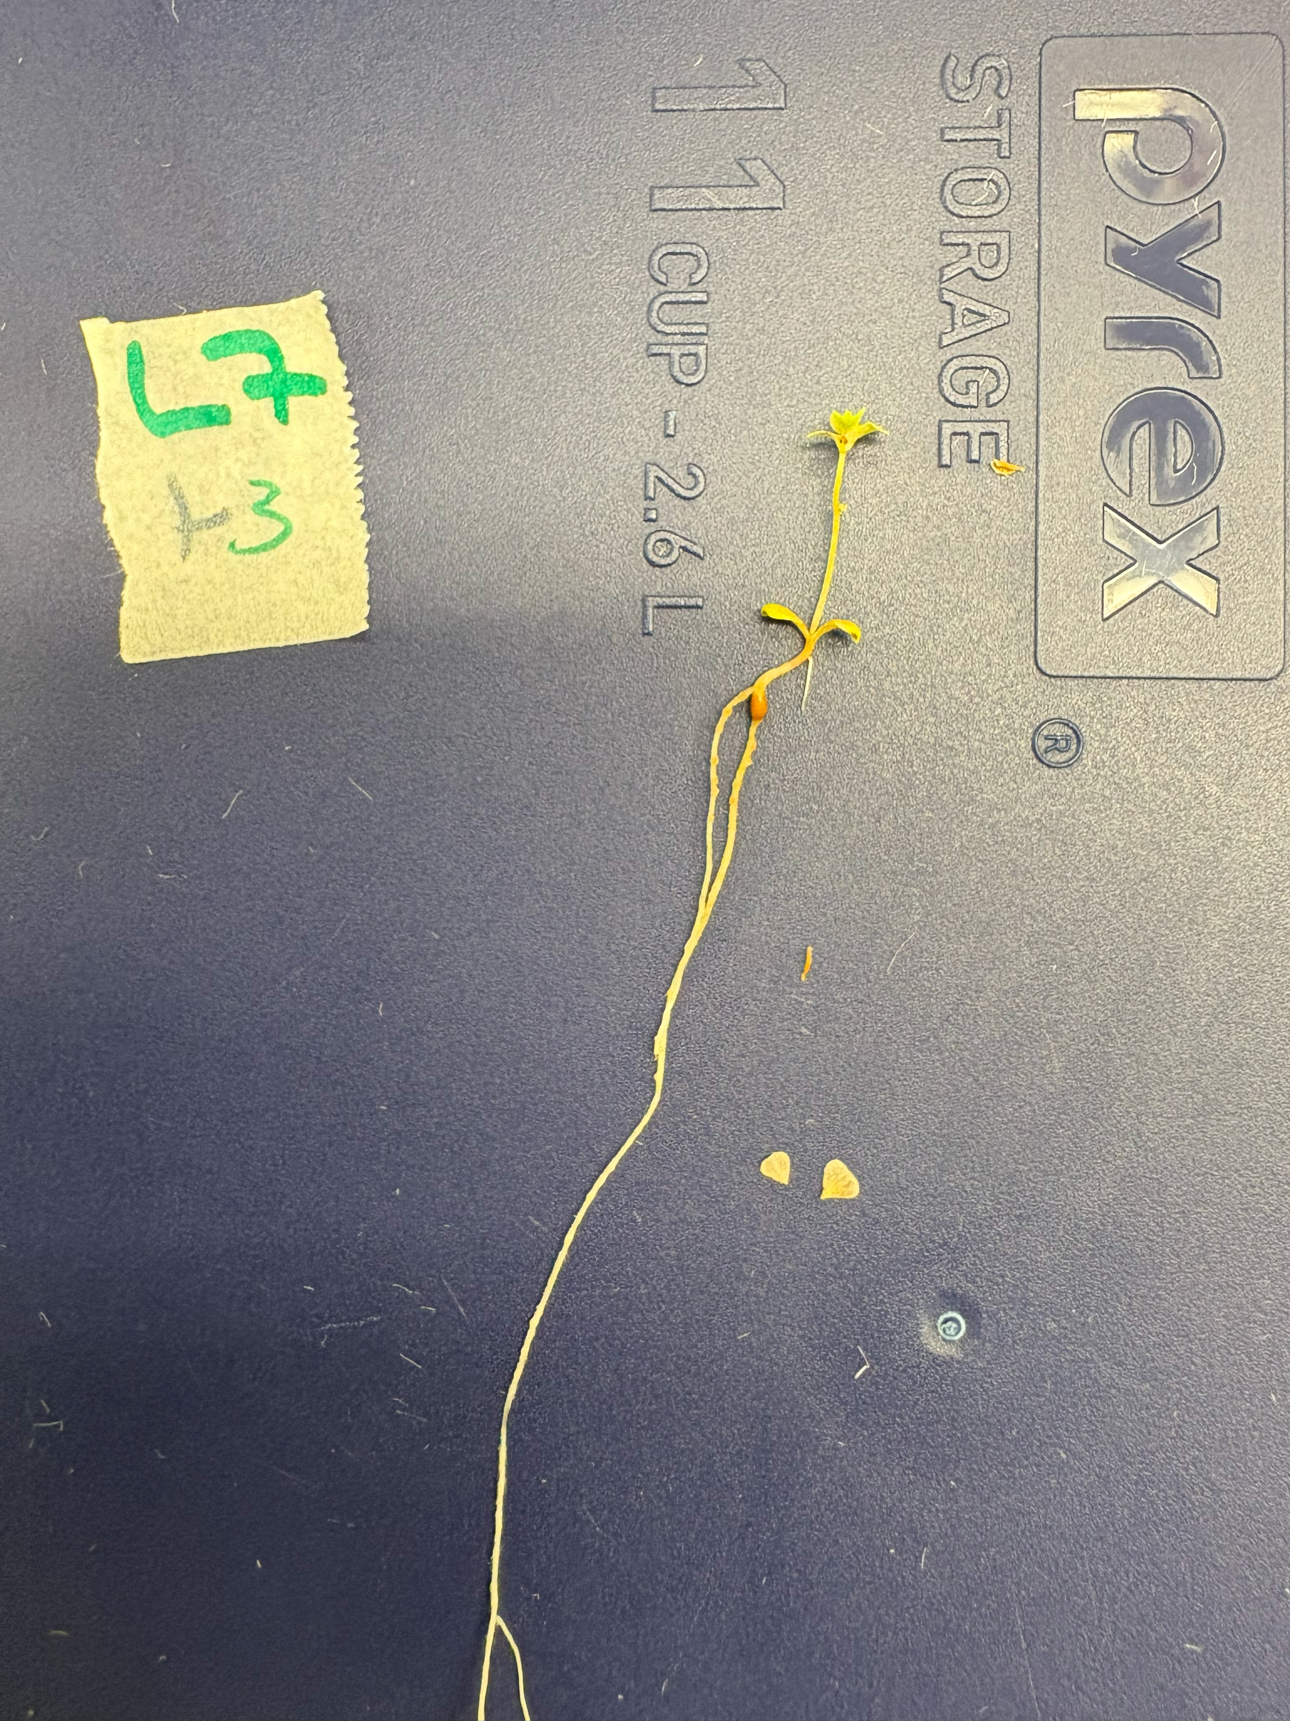

**Supplementary Figure 3b.** *L. uliginosus* GLOC005 bump-presenting subjects (left: L7+4, right: L7+5).

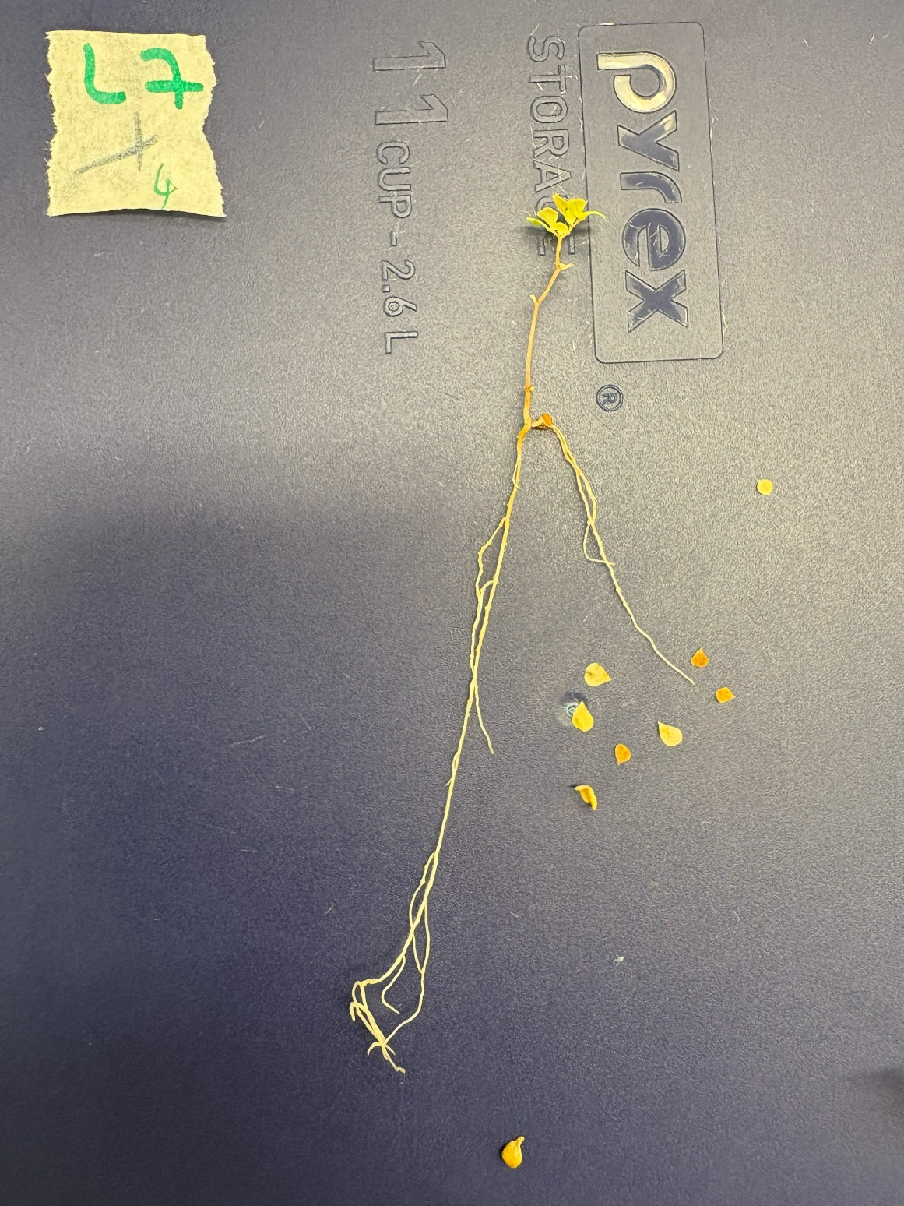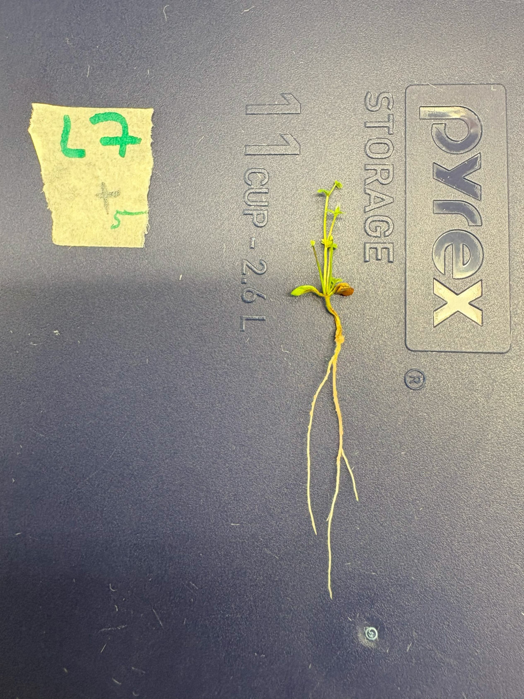

**Weight Assay One-Way ANOVA assumption plots**

**Supplementary Figure 4.** Plots referenced to ensure the dry foliage weight data meets the necessary assumptions for a One-Way ANOVA. **a)** Plot of fitted values against residuals Residuals vs Fitted plot to assess homogeneity of variance. The reasonably flat fitted line indicates that the residuals are reasonably equal between groups **b)** a Normal Q-Q plot to assess the normality of data. The majority of points are close to the line, suggesting that the data is reasonably normal

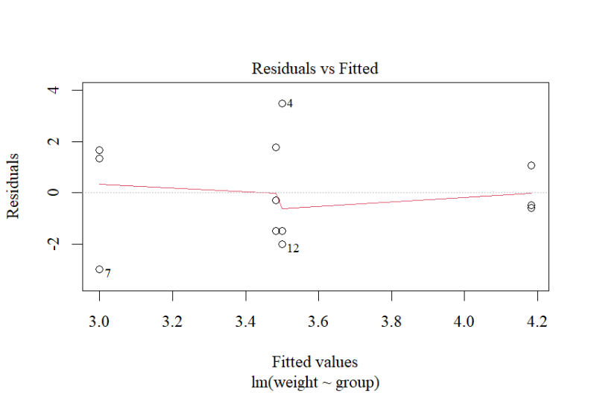

**a)**

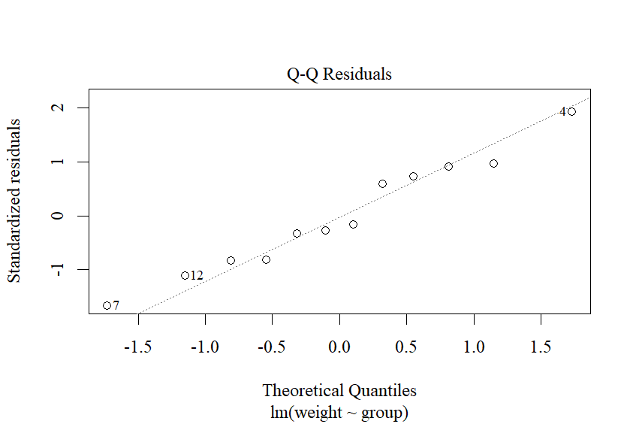

**b)**